# Analyses Viewing the Outcome Variables as a Multivariate Response

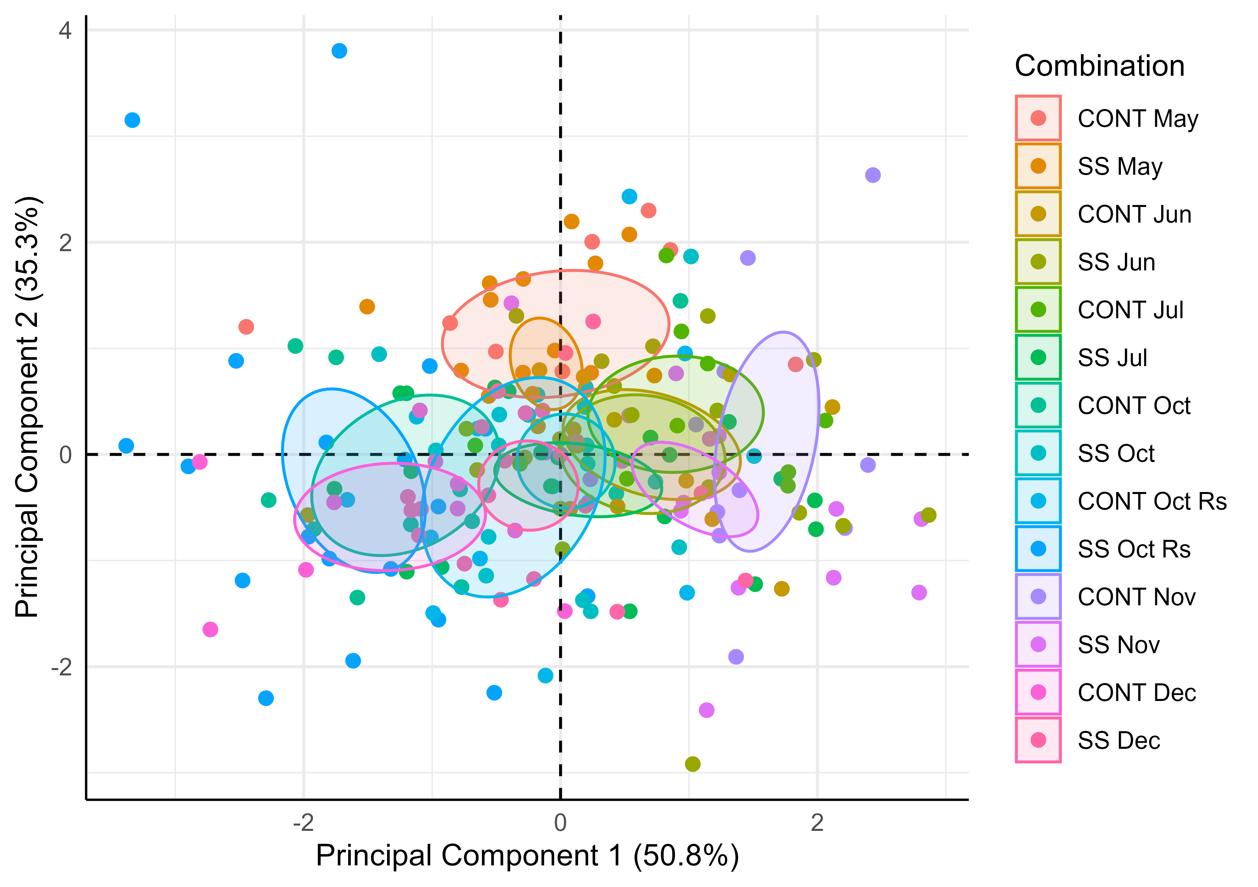

PCA Ellipse-Confidence

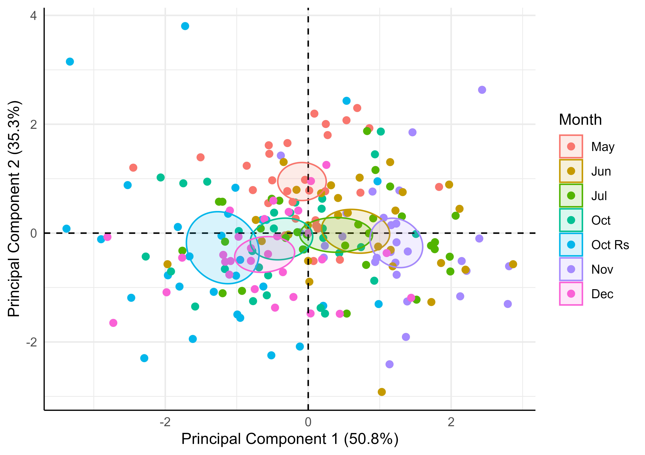

PCA Pooled Across-Group Ellipse-Confidence

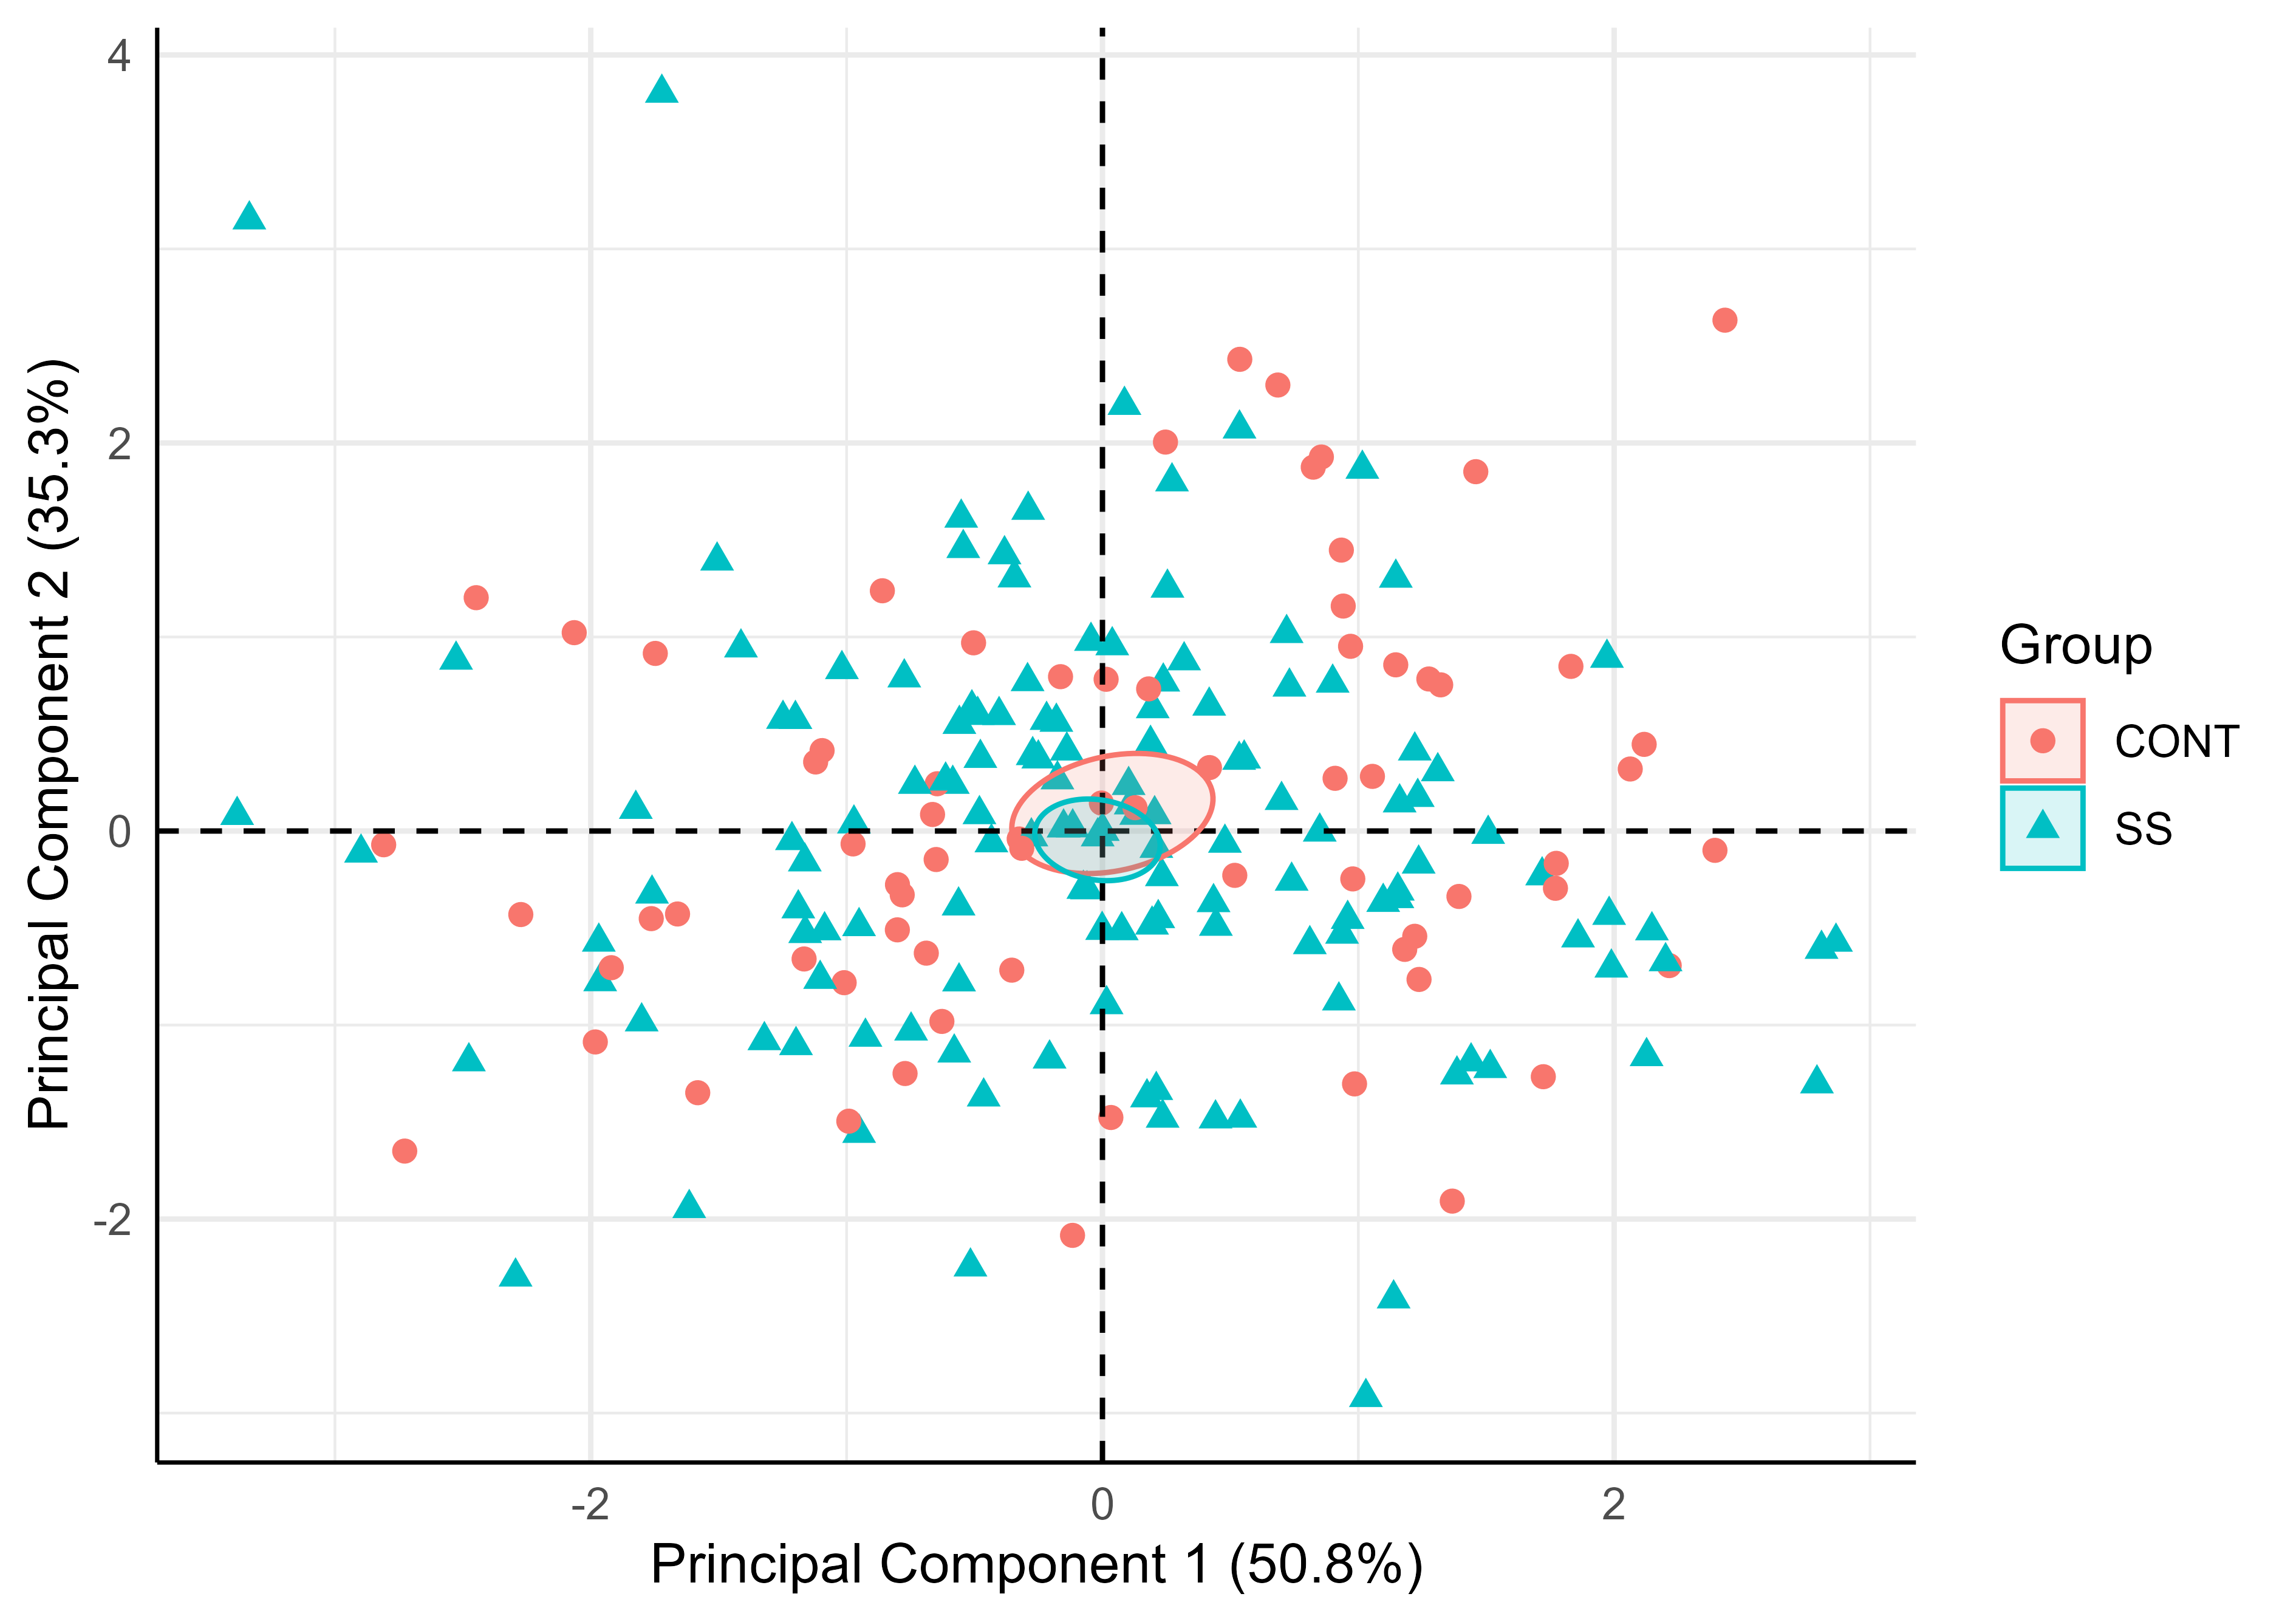

PCA Pooled Across-Month Ellipse-Confidence

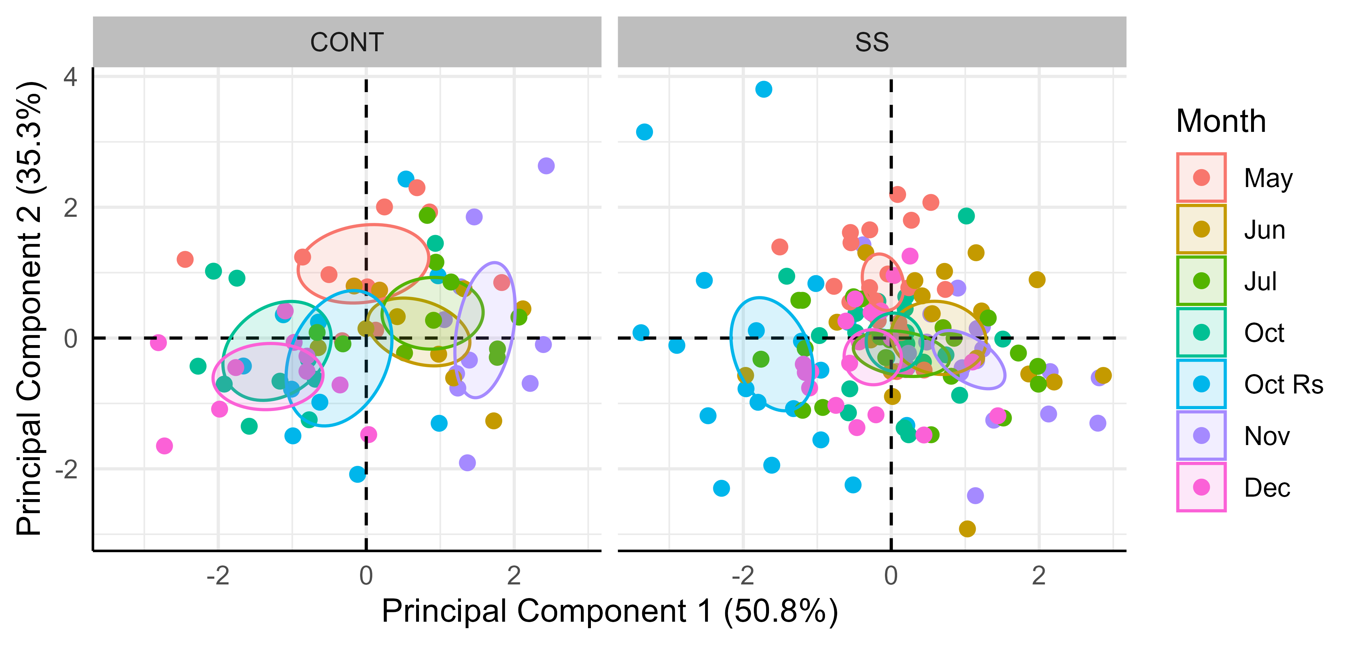

PCA Facet-Group Ellipse-Confidence

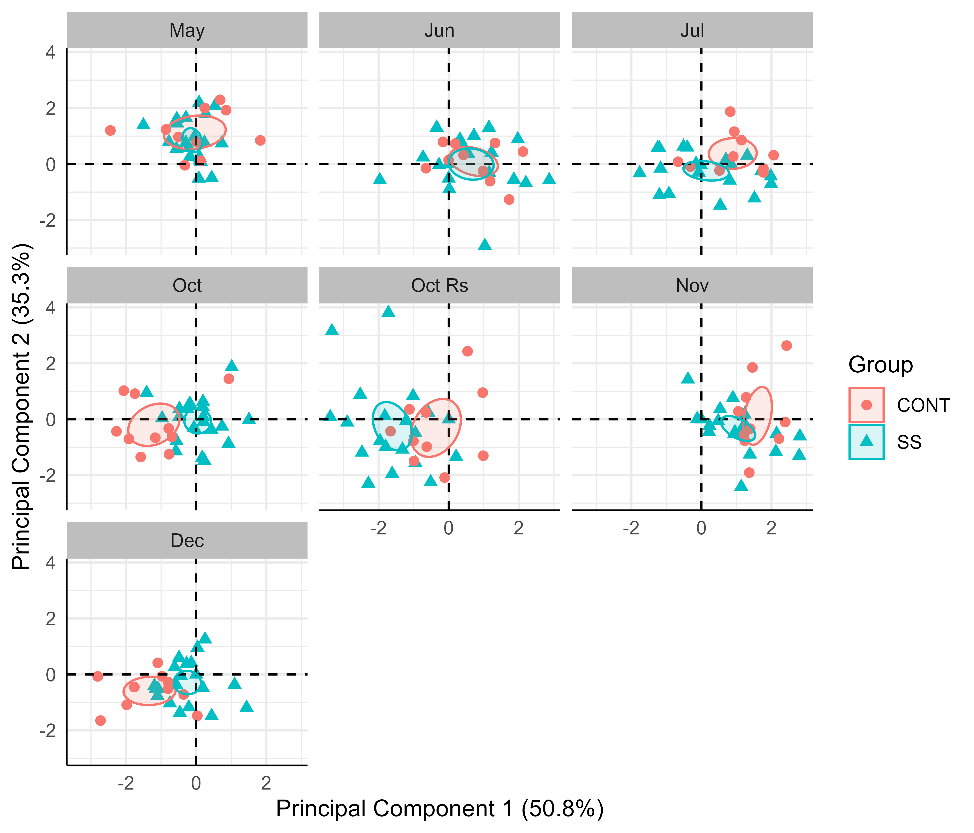

PCA Facet-Month Ellipse-Confidence

The 50.8% and 35.3% values in the axes of the figures above describe the percent variation in the data explained by the first and second principal components, respectively.

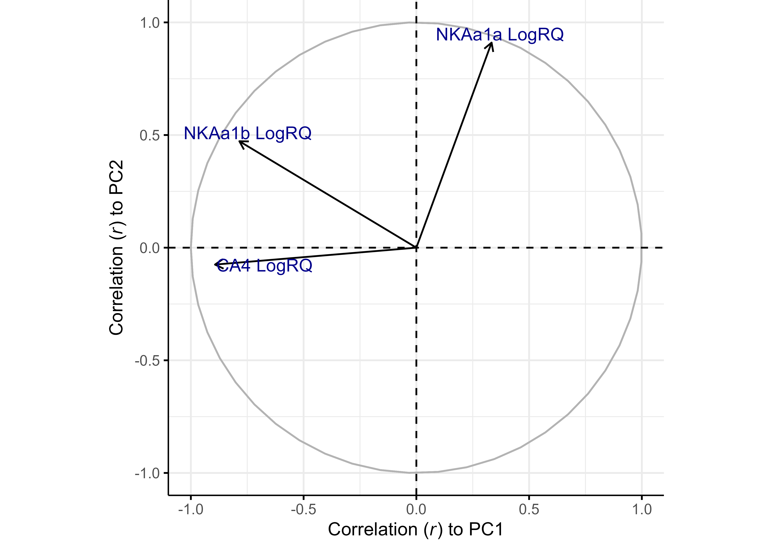

Correlation of Variables to PCs

Table 1. Pearson correlation coefficient (r) between variables and principal components

|  | NKAa1a LogRQ | NKAa1b LogRQ | CA4 LogRQ | PC1 | PC2 |
| --- | --- | --- | --- | --- | --- |
| NKAa1a LogRQ | 1.0000 | 0.0702 | -0.2579 | 0.3337 | 0.9104 |
| NKAa1b LogRQ | 0.0702 | 1.0000 | 0.4877 | -0.7850 | 0.4725 |
| CA4 LogRQ | -0.2579 | 0.4877 | 1.0000 | -0.8931 | -0.0751 |
| PC1 | 0.3337 | -0.7850 | -0.8931 | 1.0000 | 0.0000 |
| PC2 | 0.9104 | 0.4725 | -0.0751 | 0.0000 | 1.0000 |

Table 2. Contribution of variables to principal components

| Variable | ContributionPC1 | EigenvectorPC1 | ContributionPC2 | EigenvectorPC2 |
| --- | --- | --- | --- | --- |
| CA4 LogRQ | 52.295811 | -0.7231584 | 0.5331798 | -0.07301916 |
| NKAa1b LogRQ | 40.401054 | -0.6356182 | 21.1080161 | 0.45943461 |
| NKAa1a LogRQ | 7.303135 | 0.2702431 | 78.3588041 | 0.88520508 |

The contribution describes how much (in %) of the PC is composed of that variable; a more precise definition is that it is the variable's eigenvector^2 when the sum of eigenvectors^2 (over all variables) is equal to 1 (100%) for each PC (this condition is implicit in PCA). The eigenvector represents both the magnitude and direction of change of the principal component for each unit increase of the variable. This variable is in the standardized scale (z-score normalized) if scale and center arguments are set to TRUE.

Table 3. Contribution of variables to linear discriminants of Group

| Variable | ContributionLD1 | CoefficientLD1 |
| --- | --- | --- |
| CA4 LogRQ | 54.284664 | 1.0846058 |
| NKAa1b LogRQ | 44.634038 | -0.9834820 |
| NKAa1a LogRQ | 1.081299 | 0.1530757 |

LD1 and LD2 explain 100% and NA% of the separation between Group, respectively.

Table 4. Contribution of variables to linear discriminants of Month

| Variable | ContributionLD1 | CoefficientLD1 | ContributionLD2 | CoefficientLD2 |
| --- | --- | --- | --- | --- |
| NKAa1b LogRQ | 43.31385 | -0.6785341 | 60.137794 | 1.1896805 |
| CA4 LogRQ | 38.33142 | -0.6383160 | 38.031685 | -0.9460833 |
| NKAa1a LogRQ | 18.35473 | 0.4417049 | 1.830521 | 0.2075601 |

LD1 and LD2 explain 58.5% and 39.8% of the separation between Month, respectively.

Tabulated values are based on Linear Discriminant Analysis (LDA). The contribution describes the percentage of the linear discriminant composed of that variable; a more exact definition is that it is the variable's coefficient of linear discriminant^2 when the sum of coefficients^2 (across variables) is normalized to 100%. The coefficient of linear discriminant describes the magnitude and direction of change in the linear discriminant score (towards a particular factor level) per unit increase of the variable. Apart from the coefficients relative signs and magnitude, they may be difficult to interpret without an associated LDA plot.

Table 5. MANOVA Results (p-values)

| Factor | MANOVA |
| --- | --- |
| Group | 0.07274 |
| Month | 2.2000e-16 |
| Group:Month | 7.5880e-07 |

The MANOVA conducted here uses the type 3 method for partitioning sums of squares between factors. Typing is relevant only when there are multiple factors.